Title

Title (if necessary)

Taro Denshi*, Jiro Denshi (Nihon Denki University) Saburo Denshi, Shiro Denshi (Sekai Electric Power Company)

Goro Denki, Rokuro Denki (World University)

The quick brown fox jump over the lazy dog. The quick brown fox jump over the lazy dog. The quick brown fox jump over the lazy dog. The quick brown fox jump over the lazy dog. The quick brown fox jump over the lazy dog. The quick brown fox jump over the lazy dog. The quick brown fox jump over the lazy dog. The quick brown fox jump over the lazy dog. The quick brown fox jump over the lazy dog. The quick brown fox jump over the lazy dog. The quick brown fox jump over the lazy dog. The quick brown fox jump over the lazy dog. The quick brown fox jump over the lazy dog. The quick brown fox jump over the lazy dog.

**Keywords**: keyword1, keyword2, keyword3, keyword4, keyword5, keyword6

1. Heading

Text (Times New Roman 9P) □□□□□□□□□□□□□□□□□□□□□□□□□□□□□□□□□□□□□□□□□□□□□□□□□□□□□□□□□□□□□□□□□□□□□□□□□□□□□□□□□□□□□□□□□□□□□□□□□□□□□□□□□.

2. Heading

<2･1> Subheading□□□□□□□□□□□□□□□□□□□□□□□□□□□□□□□□□□□□□□□□□□□□□□Citations(1)□□Citations(2)(3)□□Citations(4)～(5)□□□□□□□□□.

Text (Times New Roman 9P) □□□□□□□□□□□□□□□□□□□□□□□□□□□□□□□□□□□□□□□□□□□□□□□□□□□□□□□□□□□□□□□□□□□□□□□□□□□□□□□□□□□□□□□□□□□□□□□□□□□□□□□□□.

(1) □□□□□　　□□□□□□□□□□□□□□□□□□□□□□□□□□□□□□□□□□□.

(2) □□□□□□□□□　　□□□□□□□□□□□□□□□□□□□□□□□□□□□□□□□.

<2･2> Subheading□□□□□□□□□□□□□□□□□□□□□□□□□□□□□□□□□□□□□□□□□□□□□□□□□□□□□□□□□□□□□□□□.

Text (Times New Roman 9P) □□□□□□□□□□□□□□□□□□□□□□□□□□□□□□□□□□□□□□□□□□□□□□□□□□□□□□□□□□□□□□□□□□□□□□□□□□□□□□□□□□□□□□□□□□□□□□□□□□□□□□□□□.

Text (Times New Roman 9P)□□□□□□□□□□□□□□□□□□□□□□□□□□□□□□□□□□□□□□□□□□□□□□□□□□□□□□□□□□□□□□□□□□□□□□□□□.

 (1)

Text□□□□□□□□□□□□□□□□□□□□□□□□□.



｛formula｝ (2)

Explanation of formula□10□□□□15□□□□20□□□□□□□□□□□10□□□□15□□□□20□□□□□□□□.

 (3)

Text (Times New Roman 9P) □□□□□□□□□□□□□□□□□□□□□□□□□□□□□□□□□□□□□□□□□□□□□□□□□□□□□□□□□□□□□(Table 1).

Table 1.　Title.

|  |  |  |  |  |
| --- | --- | --- | --- | --- |
| Text |  |  |  |  |
| Text |  |  |  |  |
|  |  |  |  |  |

Chart explanation(left)□□10□□□□15□□□□20□□□The left and right sides of the table are within 75 mm.

□□□□□□□□□□□□□□□□□□□□□□□□□□□□□□□□□□□□□□□□□□□□(Table 2).

Text (Times New Roman 9P) □□□□□□□□□□□□□□□□□□□□□□□□□□□□□□□□□□□□□□□□□□□□□□□□□□□□□□□□□□□□□□□□□□□□□□□□□□□□□□□□□□□□□□□□□□□□□□□□□□□□□□□□□(Fig. 1).

Table 2.　Title.

|  |  |  |  |  |  |  |  |  |  |  |
| --- | --- | --- | --- | --- | --- | --- | --- | --- | --- | --- |
| Text |  |  |  |  |  |  |  |  |  |  |
| Text |  |  |  |  |  |  |  |  |  |  |
|  |  |  |  |  |  |  |  |  |  |  |

Chart explanation(center)□□□□□□The left and right sides of the table are within 165 mm.

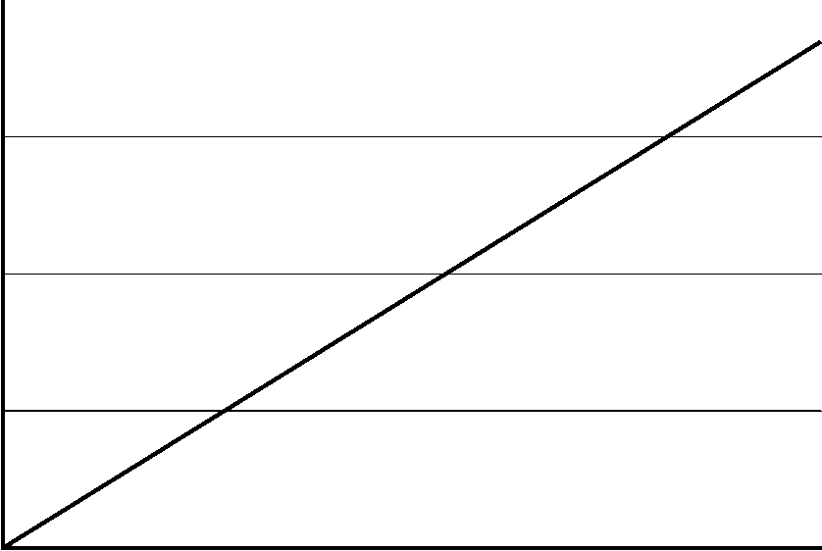

Fig. 1.　Title.

The quick brown fox jump over the lazy dog. The quick brown fox jump over the lazy dog. The quick brown fox jump over the lazy dog. The quick brown fox jump over the lazy dog. The quick brown fox jump over the lazy dog. The quick brown fox jump over the lazy dog. The quick brown fox jump over the lazy dog. The quick brown fox jump over the lazy dog. The quick brown fox jump over the lazy dog. The quick brown fox jump over the lazy dog. The quick brown fox jump over the lazy dog.

The quick brown fox jump over the lazy dog. The quick brown fox jump over the lazy dog. The quick brown fox jump over the lazy dog. The quick brown fox jump over the lazy dog. The quick brown fox jump over the lazy dog. The quick brown fox jump over the lazy dog. The quick brown fox jump over the lazy dog. The quick brown fox jump over the lazy dog. The quick brown fox jump over the lazy dog. The quick brown fox jump over the lazy dog. The quick brown fox jump over the lazy dog.

The quick brown fox jump over the lazy dog. The quick brown fox jump over the lazy dog. The quick brown fox jump over the lazy dog. The quick brown fox jump over the lazy dog. The quick brown fox jump over the lazy dog. The quick brown fox jump over the lazy dog. The quick brown fox jump over the lazy dog. The quick brown fox jump over the lazy dog. The quick brown fox jump over the lazy dog. The quick brown fox jump over the lazy dog. The quick brown fox jump over the lazy dog.

The quick brown fox jump over the lazy dog. The quick brown fox jump over the lazy dog. The quick brown fox jump over the lazy dog. The quick brown fox jump over the lazy dog. The quick brown fox jump over the lazy dog. The quick brown fox jump over the lazy dog. The quick brown fox jump over the lazy dog. The quick brown fox jump over the lazy dog. The quick brown fox jump over the lazy dog. The quick brown fox jump over the lazy dog. The quick brown fox jump over the lazy dog.

The quick brown fox jump over the lazy dog. The quick brown fox jump over the lazy dog. The quick brown fox jump over the lazy dog. The quick brown fox jump over the lazy dog. The quick brown fox jump over the lazy dog. The quick brown fox jump over the lazy dog. The quick brown fox jump over the lazy dog. The quick brown fox jump over the lazy dog. The quick brown fox jump over the lazy dog. The quick brown fox jump over the lazy dog. The quick brown fox jump over the lazy dog.

The quick brown fox jump over the lazy dog. The quick brown fox jump over the lazy dog. The quick brown fox jump over the lazy dog. The quick brown fox jump over the lazy dog. The quick brown fox jump over the lazy dog. The quick brown fox jump over the lazy dog. The quick brown fox jump over the lazy dog. The quick brown fox jump over the lazy dog. The quick brown fox jump over the lazy dog. The quick brown fox jump over the lazy dog. The quick brown fox jump over the lazy dog.

The quick brown fox jump over the lazy dog. The quick brown fox jump over the lazy dog. The quick brown fox jump over the lazy dog. The quick brown fox jump over the lazy dog. The quick brown fox jump over the lazy dog. The quick brown fox jump over the lazy dog. The quick brown fox jump over the lazy dog. The quick brown fox jump over the lazy dog. The quick brown fox jump over the lazy dog. The quick brown fox jump over the lazy dog. The quick brown fox jump over the lazy dog.

The quick brown fox jump over the lazy dog. The quick brown fox jump over the lazy dog. The quick brown fox jump over the lazy dog. The quick brown fox jump over the lazy dog. The quick brown fox jump over the lazy dog. The quick brown fox jump over the lazy dog. The quick brown fox jump over the lazy dog. The quick brown fox jump over the lazy dog. The quick brown fox jump over the lazy dog. The quick brown fox jump over the lazy dog. The quick brown fox jump over the lazy dog.

The quick brown fox jump over the lazy dog. The quick brown fox jump over the lazy dog. The quick brown fox jump over the lazy dog. The quick brown fox jump over the lazy dog. The quick brown fox jump over the lazy dog. The quick brown fox jump over the lazy dog. The quick brown fox jump over the lazy dog. The quick brown fox jump over the lazy dog. The quick brown fox jump over the lazy dog. The quick brown fox jump over the lazy dog. The quick brown fox jump over the lazy dog.

The quick brown fox jump over the lazy dog. The quick brown fox jump over the lazy dog. The quick brown fox jump over the lazy dog. The quick brown fox jump over the lazy dog. The quick brown fox jump over the lazy dog. The quick brown fox jump over the lazy dog. The quick brown fox jump over the lazy dog. The quick brown fox jump over the lazy dog. The quick brown fox jump over the lazy dog. The quick brown fox jump over the lazy dog. The quick brown fox jump over the lazy dog.

The quick brown fox jump over the lazy dog. The quick brown fox jump over the lazy dog. The quick brown fox jump over the lazy dog. The quick brown fox jump over the lazy dog. The quick brown fox jump over the lazy dog. The quick brown fox jump over the lazy dog. The quick brown fox jump over the lazy dog. The quick brown fox jump over the lazy dog. The quick brown fox jump over the lazy dog. The quick brown fox jump over the lazy dog. The quick brown fox jump over the lazy dog.

The quick brown fox jump over the lazy dog. The quick brown fox jump over the lazy dog. The quick brown fox jump over the lazy dog. The quick brown fox jump over the lazy dog. The quick brown fox jump over the lazy dog. The quick brown fox jump over the lazy dog. The quick brown fox jump over the lazy dog. The quick brown fox jump over the lazy dog. The quick brown fox jump over the lazy dog. The quick brown fox jump over the lazy dog. The quick brown fox jump over the lazy dog.

The quick brown fox jump over the lazy dog. The quick brown fox jump over the lazy dog. The quick brown fox jump over the lazy dog. The quick brown fox jump over the lazy dog. The quick brown fox jump over the lazy dog. The quick brown fox jump over the lazy dog. The quick brown fox jump over the lazy dog. The quick brown fox jump over the lazy dog. The quick brown fox jump over the lazy dog. The quick brown fox jump over the lazy dog. The quick brown fox jump over the lazy dog.

The quick brown fox jump over the lazy dog. The quick brown fox jump over the lazy dog. The quick brown fox jump over the lazy dog. The quick brown fox jump over the lazy dog. The quick brown fox jump over the lazy dog. The quick brown fox jump over the lazy dog. The quick brown fox jump over the lazy dog. The quick brown fox jump over the lazy dog. The quick brown fox jump over the lazy dog. The quick brown fox jump over the lazy dog. The quick brown fox jump over the lazy dog.

References

(1) Author: “Title”, Journal title, Vol.00, No.00 pp.000-111 (pub. year)

(2) Author and Author: “Title”, Journal title, Vol.00, No.00 pp.000-111 (pub. year)

(3) Author, Author, and Author: “Title”, Journal title, Vol.00, No.00 pp.000-111 (pub. year)